**Implementation of Barcode Inventory Management System**

**TITLE: Implementation of barcode inventory management:**

1. **FLOW DIAGRAM:**

Flow chart representation:

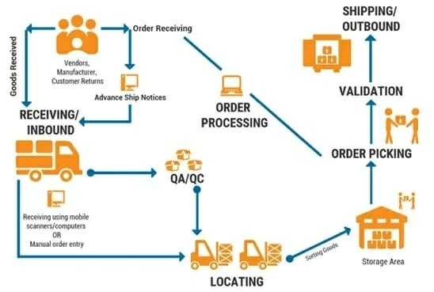

**FLOW STATES:**

1. **START:**
   * The beginning of the inventory management process.
2. **Inward Process:**
   * Actions:
     + Enter Barcode, Loan No, Doc Type, Inward Date, Location, Remarks - Inward.
     + Update Inventory Status to Inward.
   * Conditions:
     + Barcode No (Alphanumeric, divided into parts).
     + Loan No (Auto-fetched through barcode scan).
     + Doc Type (Selected based on barcode prefix).
     + Inward Date (Required for first entry).
     + Location (Location for storage for the first time).
     + Remarks - Inward (Free text).
3. **Outward Process:**
   * Actions:
     + Enter Out Date, Requested by, Retrieval Type, Approved by, Remarks - Outward.
     + Update Inventory Status to Outward.
   * Conditions:
     + Out Date (File Out Date).
     + Requested by (User specifying purpose).
     + Retrieval Type (Temporary/Permanent).
     + Approved by (Free text).
     + Remarks - Outward (Free text).
4. **Re-Inward Process:**
   * Actions:
     + Enter Re Inward Date, Location, Remarks - Re Inward.
     + Update Inventory Status to Inward.
   * Conditions:
     + Re Inward Date (File Out Date).
     + Location (Location for storage).
     + Remarks - Re Inward (Free text).
5. **End:**

* The conclusion of the inventory management process.

**2. Statement of Work (SOW):**

Project Title: Implementation of Barcode Inventory Management System

**Problem Statement:** The existing manual inventory management system lacks efficiency and real-time tracking capabilities. This project aims to implement a barcode-based system to streamline inventory processes, improve tracking accuracy, and enhance overall operational efficiency.

**Goals:**

1. Implement a user-friendly barcode inventory management system.
2. Enable real-time tracking of inventory items through barcode scanning.
3. Improve data accuracy and reduce manual data entry errors.
4. Enhance search functionality for efficient data retrieval.
5. Implement export options for comprehensive data reporting.

**Deliverables:**

1. Barcode Inventory Management System with a centralized database.
2. User interface for data entry and retrieval, incorporating barcode scanning capabilities.
3. System documentation outlining functionalities and usage guidelines.
4. Advanced search functionality for efficient data filtering.
5. Export options for extracting data from the system for reporting.

**Milestones:**

1. **Milestone 1 - System Design:**
   * Design system architecture and define database structure.
2. **Milestone 2 - Development:**
   * Implement barcode scanning functionality.
   * Develop user interface for data entry and retrieval.
3. **Milestone 3 - Testing:**
   * Conduct rigorous testing to ensure the system is error-free.
   * Gather feedback from the operation team for improvements.
4. **Milestone 4 - Deployment:**
   * Deploy the system for live use.
   * Provide training sessions for the operation team on system usage.
5. **Milestone 5 - Documentation and Support:**
   * Document system functionalities and create usage guidelines.
   * Provide ongoing support and address any post-deployment issues.

**3. Project Conclusion:**

In conclusion, the implementation of the Barcode Inventory Management System has successfully achieved the project goals outlined in the Statement of Work. The system now provides an efficient and streamlined process for tracking physical loan files, reducing manual errors, and enhancing overall operational efficiency.

**Key Achievements:**

1. **User-Friendly Interface:**
   * The implemented system features a user-friendly interface for easy data entry and retrieval.
2. **Real-Time Tracking:**
   * The integration of barcode scanning functionality enables real-time tracking of inventory items.
3. **Improved Data Accuracy:**
   * The system has successfully reduced manual data entry errors, ensuring higher data accuracy.
4. **Enhanced Search Functionality:**
   * Advanced search options facilitate efficient data retrieval, saving time and effort for users.
5. **Export Options:**
   * The system provides export options for extracting comprehensive data for reporting purposes.